13. Create a Virtual Machine with 1 CPU, 2GB RAM and 15GB storage disk using a Type 2 Virtualization Software.

Aim:
To create a Virtual Machine with 1 CPU, 2 GB RAM, and 15 GB storage using a Type-2 Hypervisor.

Procedure:
Step 1: Open the Type-2 virtualization software (VirtualBox or VMware Workstation).
Step 2: Click New, enter the virtual machine name, and select the operating system type and version.
Step 3: Allocate 2 GB (2048 MB) RAM to the virtual machine.
Step 4: Create a 15 GB virtual hard disk for the virtual machine.
Step 5: Open Settings and configure the processor to 1 CPU.
Step 6: Attach the operating system ISO file and click Start to boot the virtual machine.
Step 7: Install the operating system and verify that the virtual machine has 1 CPU, 2 GB RAM, and 15 GB storage.

Step1:
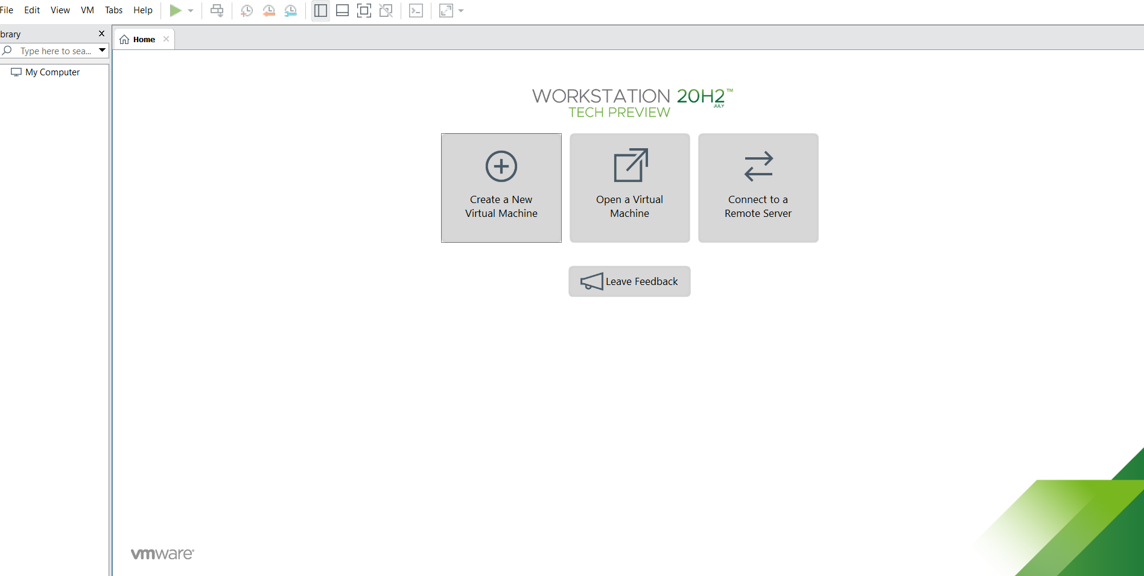

Step2:
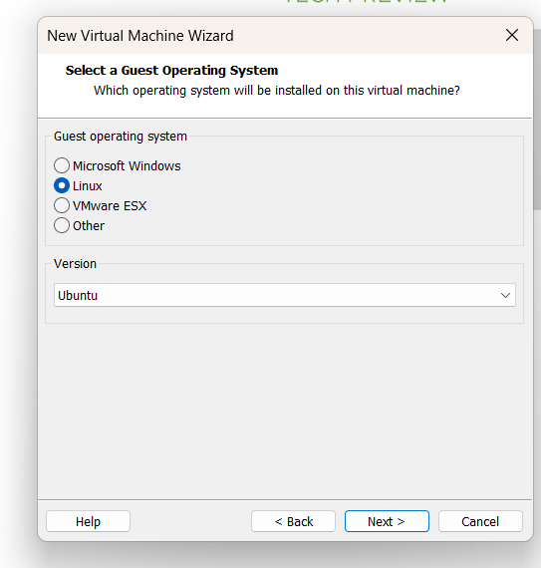

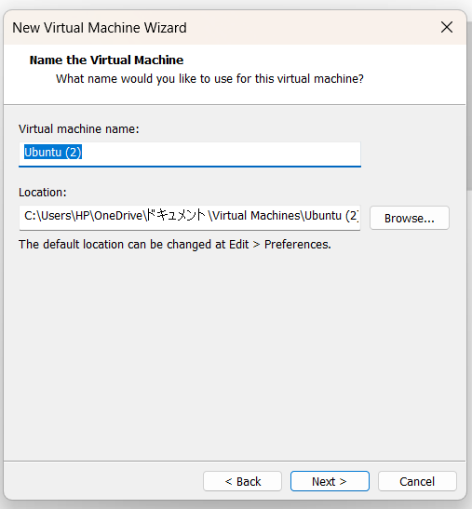

Step3:
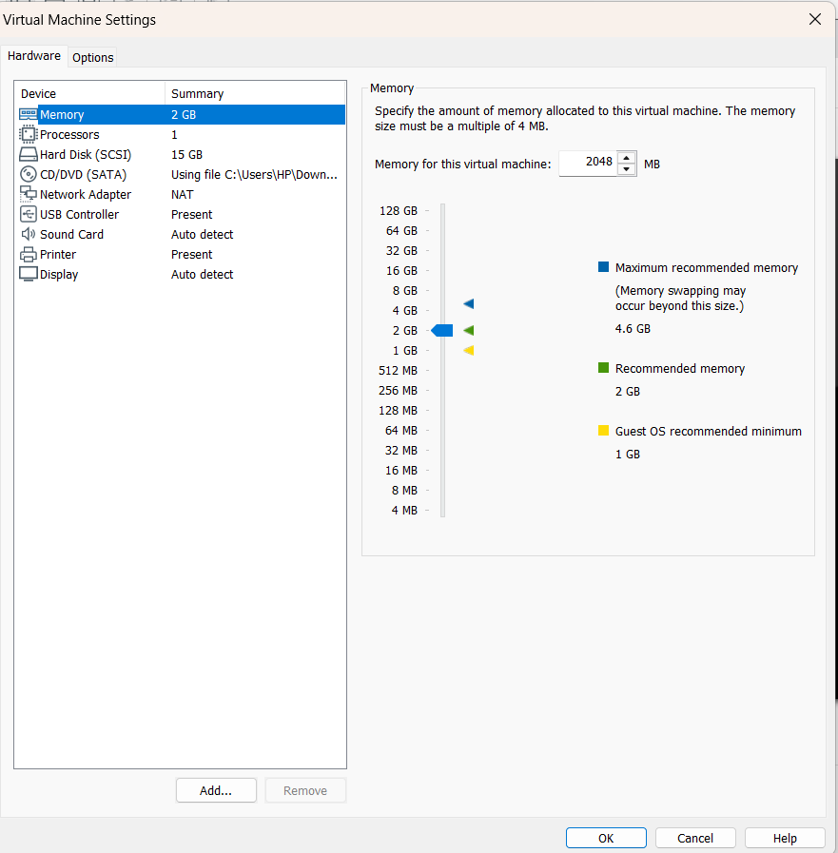

Step4:
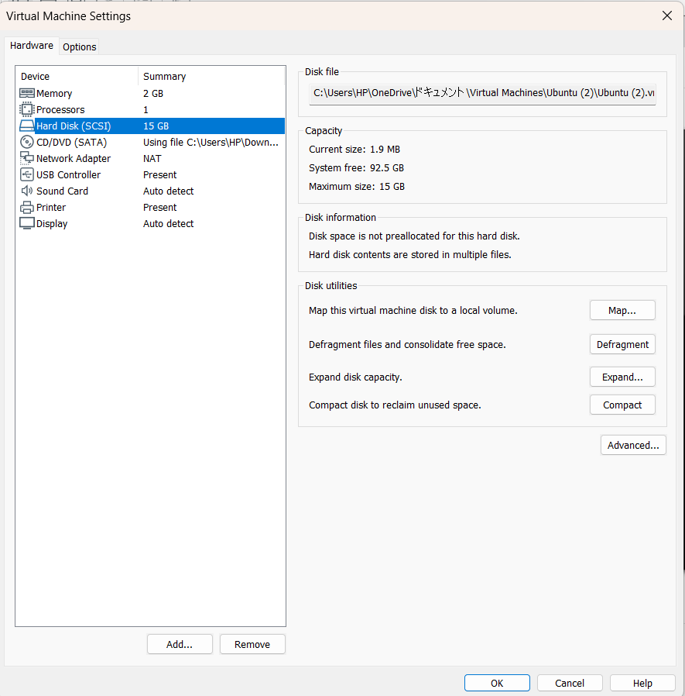

Step5:
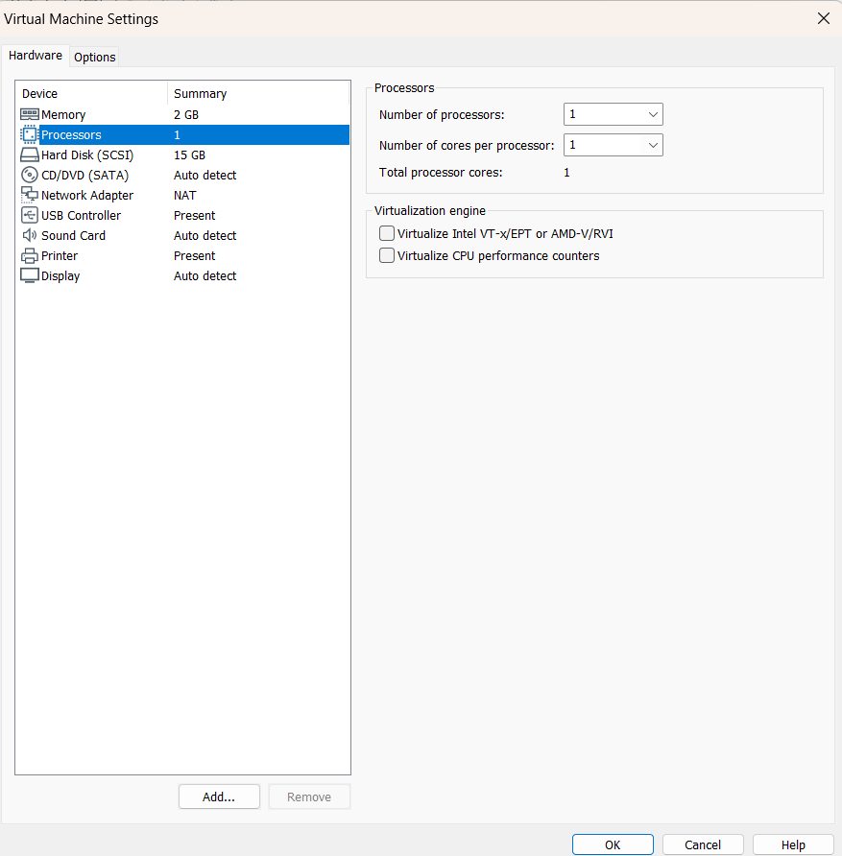

Step6:
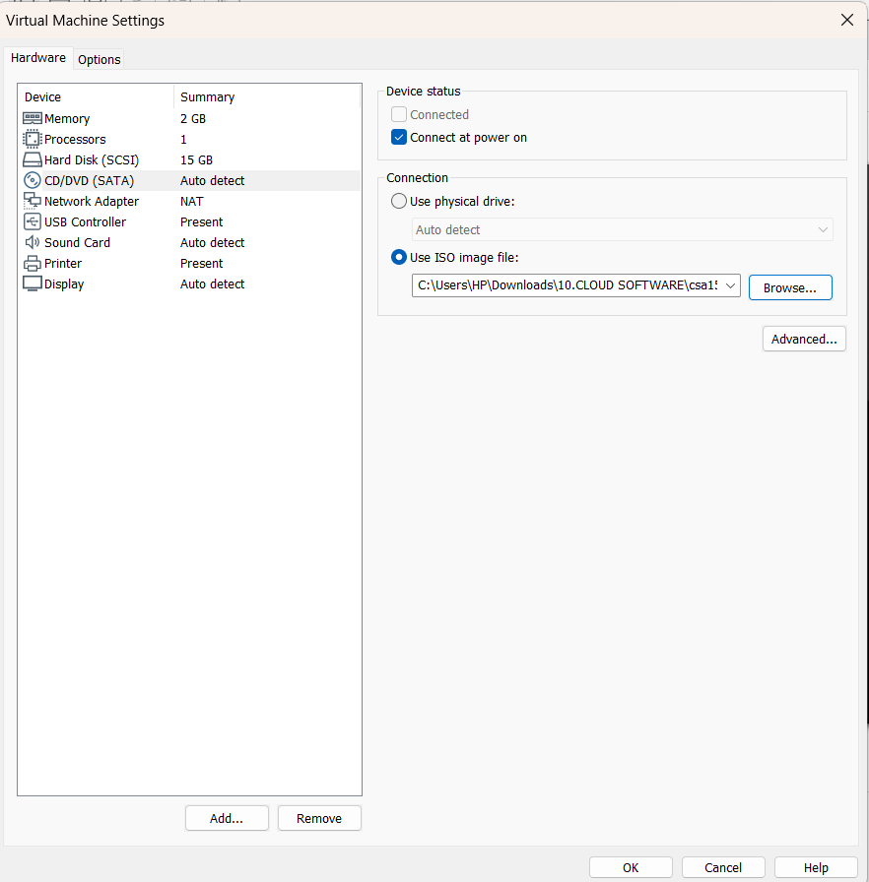

Step7:
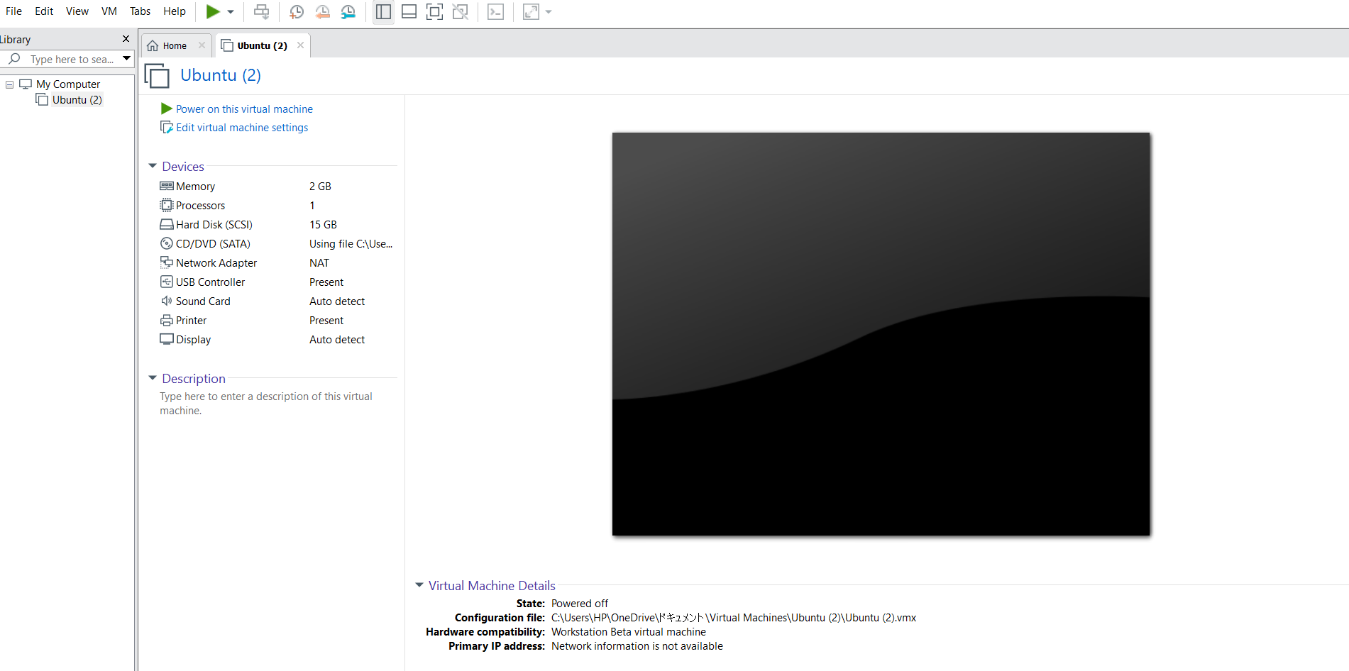

Result:
A virtual machine was successfully created using a Type-2 Hypervisor (VirtualBox/VMware Workstation) and configured with 1 CPU, 2 GB RAM, and 15 GB virtual storage. The operating system was installed and the virtual machine was verified to be functioning properly.

